Please designate an individual from your RTC to be a Contributor and notify Phyllis M. Cahaly, CMD, Director of Partnership Marketing, (phyllis.cahaly@mass.gov). The Contributor will be responsible for uploading imagery to Libris at least quarterly as outlined in your contract with MOTT. As well, a separate excel file listing the details of the photos you uploaded to Libris should be sent to Phyllis concurrently.

FY19 QUARTERLY SUBMISSION DATES:

QUARTER | UPLOAD & DETAIL FILE DUE DATE -- BY 3:00 pm
#1. July/Aug./Sept. (2018) | Thursday, November 15, 2018
#2. Oct./Nov./Dec. (2018) | Friday, February 15, 2019
#3. Jan./Feb./Mar. (2019) | Wednesday, May 15, 2019
#4. April/May/June (2019) | Wednesday, July 31, 2019

UPLOADING IMAGES TO LIBRIS
If you are the Contributor for your RTC, you will receive an email to activate your account. Depending on whether or not you have had prior experience with Libris or PhotoShelter, this email may look slightly different:
NEW LIBRIS USERS: If it's your first time interacting with Libris/PhotoShelter:
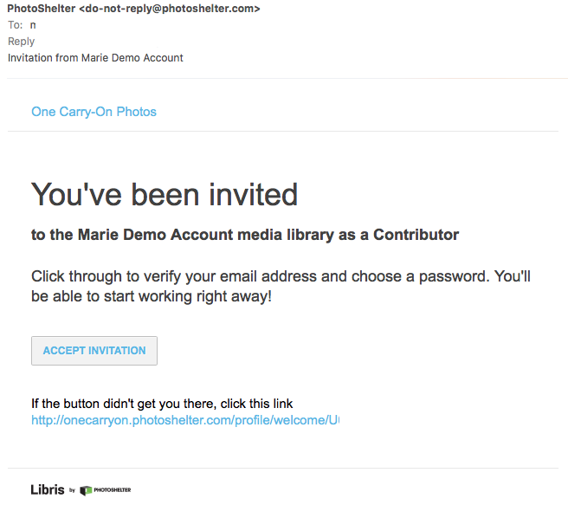
- You will have to create a new account and set a password. This password in combination with your email will be your single login for all Libris or PhotoShelter accounts you have access to, both now and the future. A sample email invitation is below.

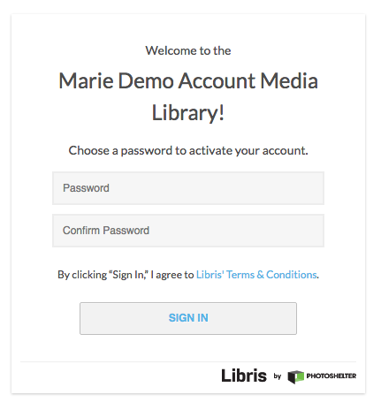
- Once you click "Accept Invitation," you'll be taken to MOTT’s Public Portal, where you'll set your password. A sample portal login is below.

- After your account is first activated, you can immediately begin uploading images by selecting “Upload”, or you can find out more about being a Contributor by clicking the “Help Center” button. Please make sure to save or bookmark the URL in your browser’s address bar for future ease of logging in.
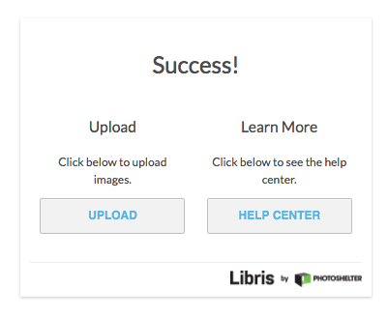

- Uploading photos - Upon landing on the upload page, you may drag files from your desktop to the designated spot on the left side of the page, or you may click into that same box to open up the file-picker and browse your computer for files to upload. Simply select a batch of files or drag files, here, and your list of files will appear on the right side of the screen.

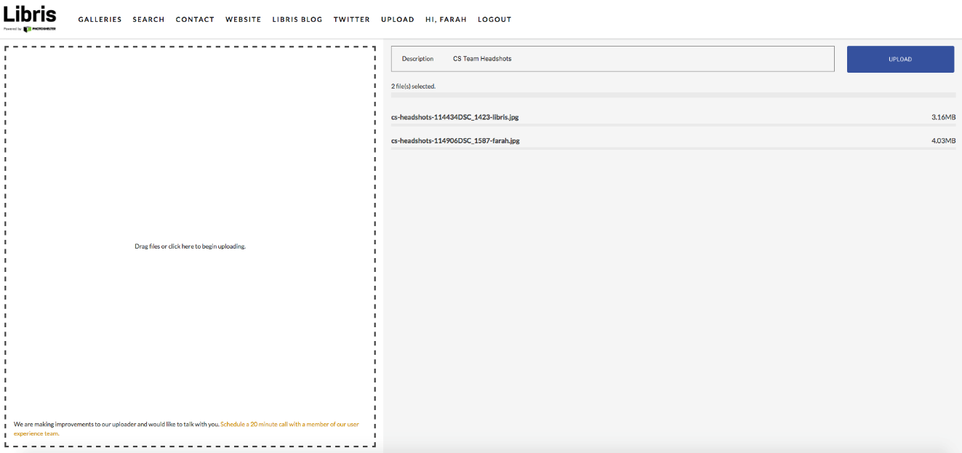
Once your selection is made, simply click "Upload" and the upload will begin. A yellow progress bar below the filename indicates the upload is in progress, and a green status bar indicates the upload is complete.
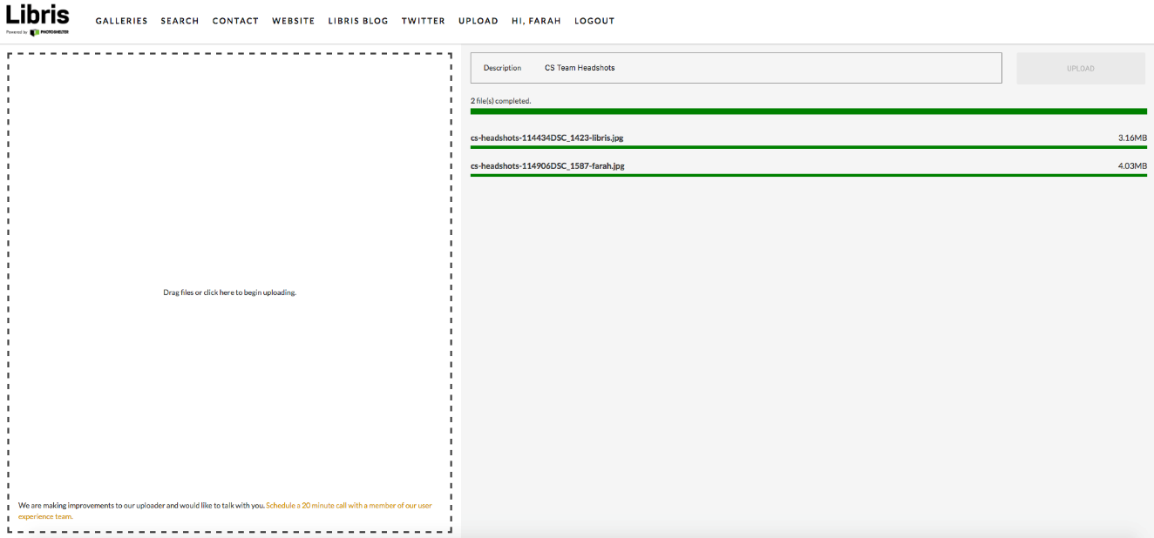

There is no limit to the number of files you may upload here at a given time, but please be advised that you will need to remain on this page until the upload completes. That's all there is to it! An alternate upload method is using the desktop uploader, if you wish for files to upload in the background without using your web browser.
EXISTING LIBRIS USERS: If you have previously set a password (for example, if you were previously invited to contribute to a different Libris account, or you already have a PhotoShelter account): you will be reminded that your email address is already registered, but you'll still need to activate your role as a Contributor with this specific organization.
Once you click "Accept Invitation," you'll be taken to MOTT’s Public Portal, where you'll be prompted to log in with your email address and password. After your account is first activated, you can go to the Contributor web uploader, or learn more about your role as a Contributor.
NAMING PHOTOS and PHOTO REPORT
When naming image files, please take note to indicate your RTC in the file name. For example:
daffodil5_spring_nantucket.jpg
Please make sure to fill out and submit an RTC Quarterly Photos excel spreadsheet reflecting details of the photo uploads. An email should be sent to Phyllis M. Cahaly, CMD, Director of Partnership Marketing, (phyllis.cahaly@mass.gov) indicating that photos have been uploaded, along with the spreadsheet as an attachment. Attention to all of the above will ensure accurate organization and tagging of image files for ease of search and distribution.

Last update: 1/29/19

